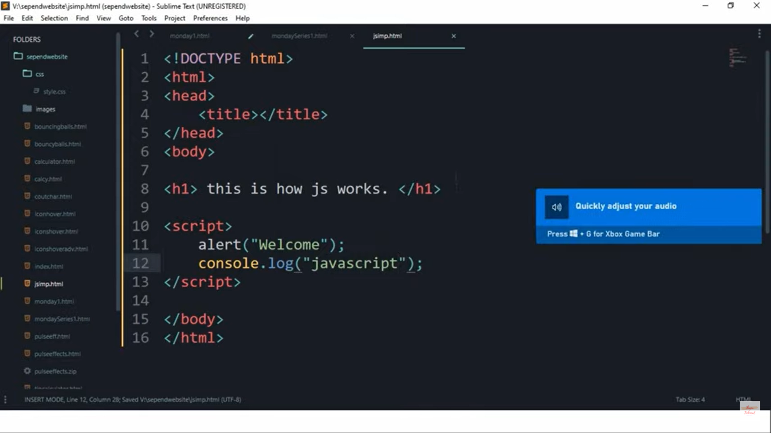

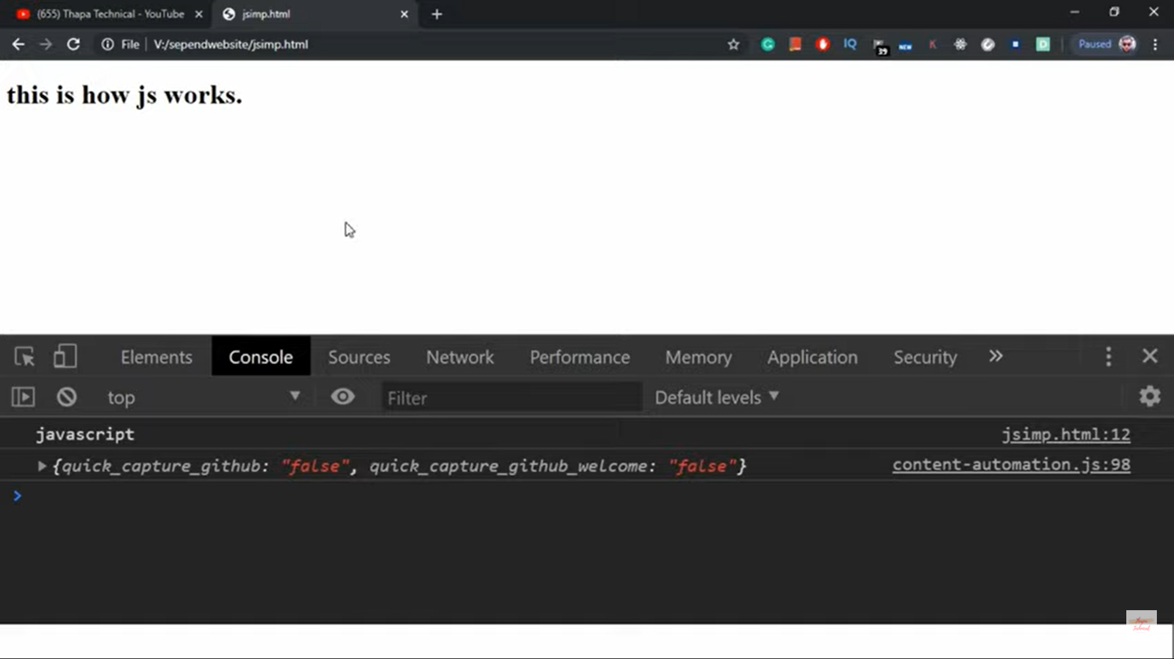

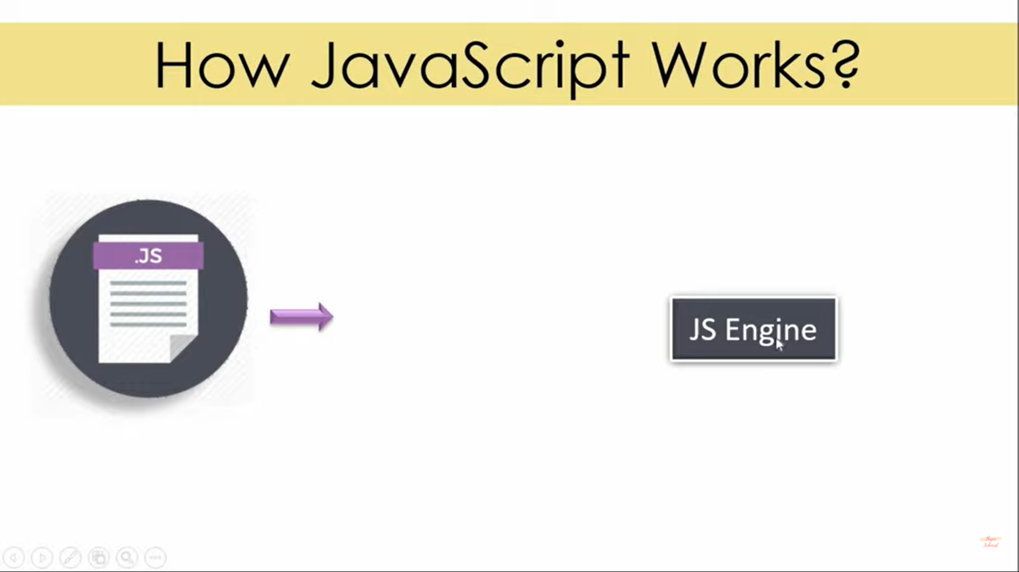

Every browser has its own js engine

Chrome :V8 Engine

Mozilla > Spidermonkey

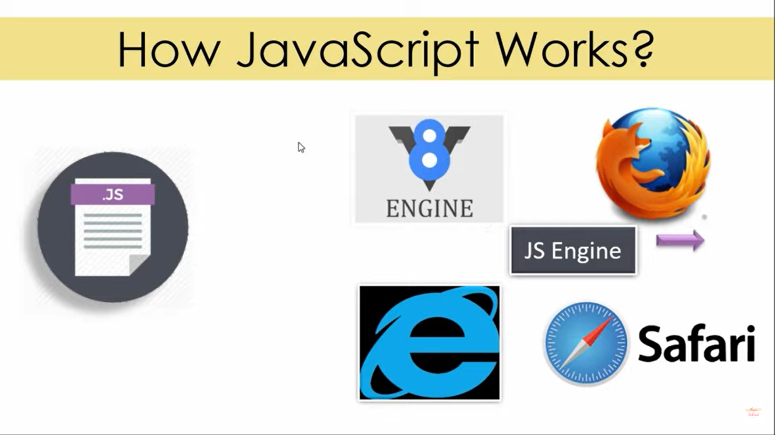

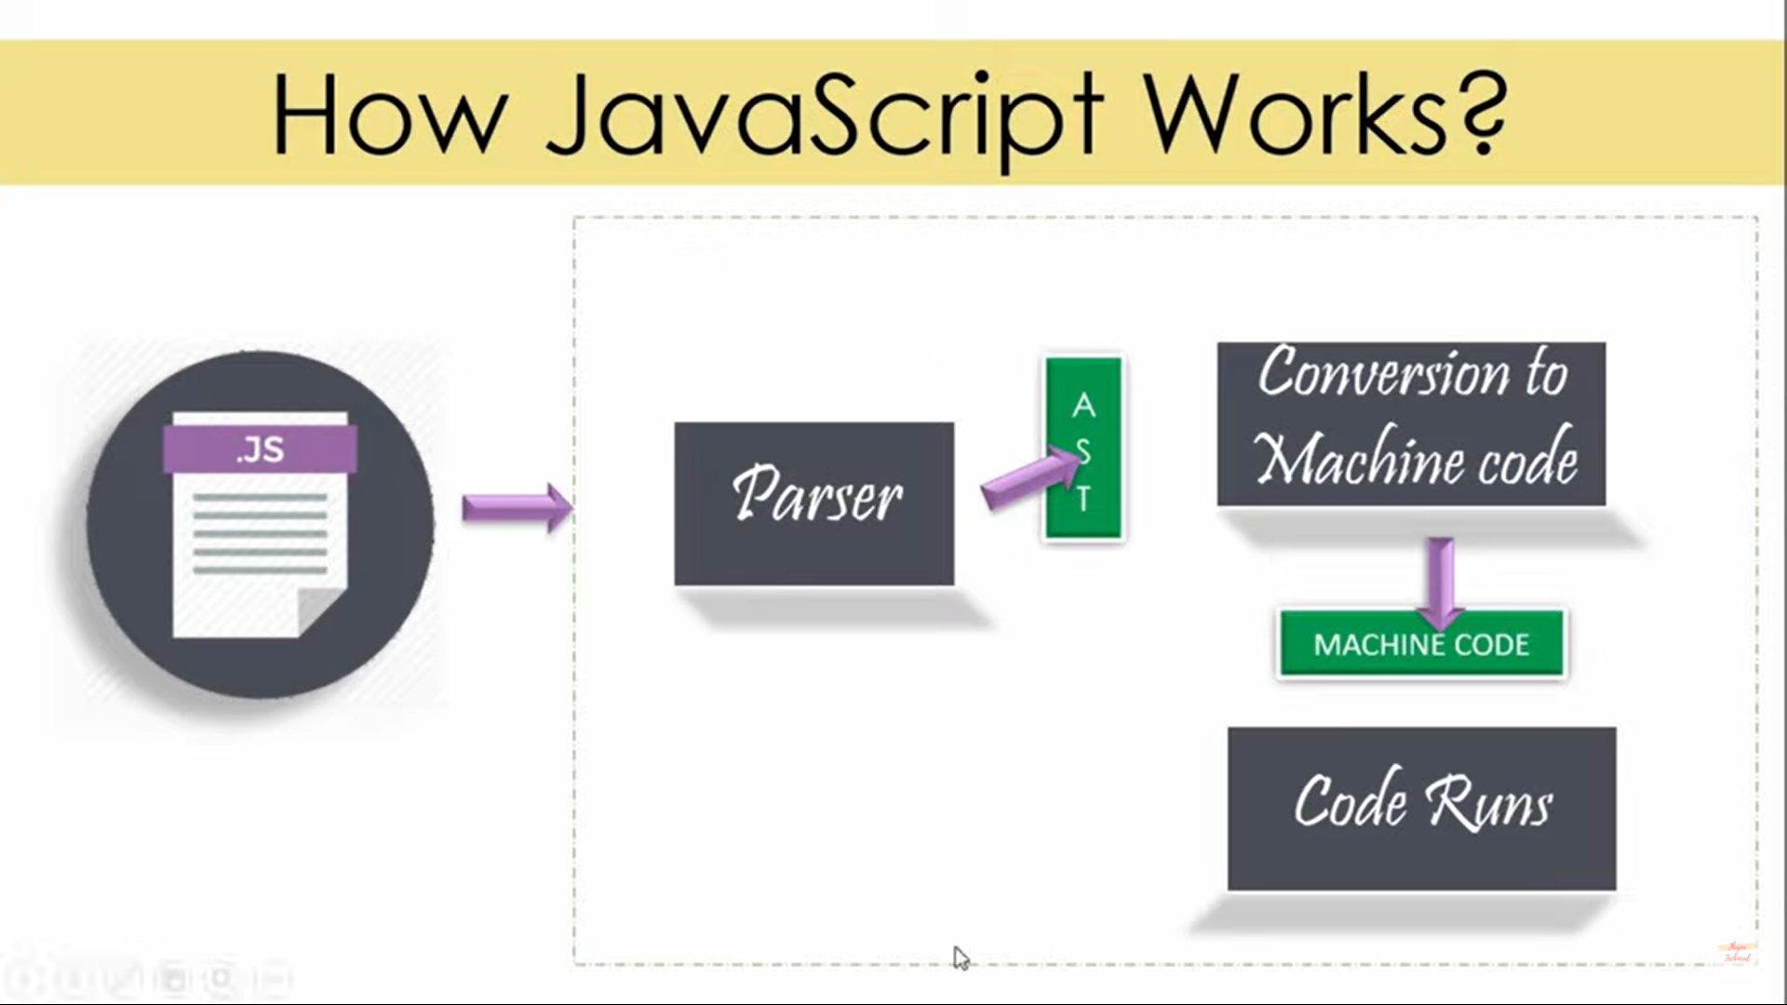

Every js engine has a parser, which parse JS code

Line by line it checks code & convert , creates a data structure ks. abstract syntax tree

